EXPERIMENT NO. 22

Pushing and Pulling Docker Images Using Docker Hub

Aim
To create a Docker image for a static HTML website, push it to Docker Hub, pull it on another machine, and run the container successfully.

Software Requirements
- Windows 10/11 (or Linux/macOS)
- Docker Desktop
- Docker Hub Account
- Visual Studio Code (or any code editor)
- Web Browser
- Internet Connection

Theory
Docker Hub is a cloud-based repository for storing and sharing Docker images. After creating a Docker image, it can be tagged and pushed to Docker Hub. Other users or systems can then pull the image from Docker Hub and run it as a container without rebuilding the application.

Procedure
Step 1: Create the Project Folder
Create a folder named static-website. Inside the folder, create:
- index.html
- Dockerfile
Step 2: Create the HTML File
Create index.html.
<!DOCTYPE html>
<html>
<head>
<title>Docker Website</title>
</head>
<body>
<h1>Welcome to Docker Hub</h1>
<p>This static website is running inside a Docker container.</p>
</body>
</html>

Step 3: Create the Dockerfile
Create Dockerfile.
FROM nginx:alpine
COPY index.html /usr/share/nginx/html/
EXPOSE 80

Step 4: Build the Docker Image
Open Terminal or Command Prompt in the project folder.
docker build -t static-website .

Verify the image.
docker images

Step 5: Login to Docker Hub
docker login

Enter your Docker Hub username and password.
Step 6: Tag the Docker Image
Replace yourusername with your Docker Hub username.
docker tag static-website yourusername/static-website:latest

Step 7: Push the Image to Docker Hub
docker push yourusername/static-website:latest

Wait until the upload is completed successfully.
Step 8: Pull the Image on Another Machine
Log in to Docker on the second machine.
docker login

Pull the image.
docker pull yourusername/static-website:latest

Step 9: Run the Docker Container
docker run -d -p 8080:80 --name static-container yourusername/static-website:latest

Verify the running container.
docker ps

Step 10: Test the Website
- Open a web browser.
- Enter the following URL: http://localhost:8080
- Verify that the static website is displayed successfully.

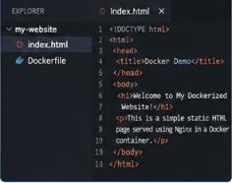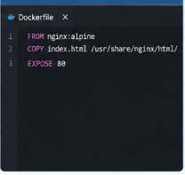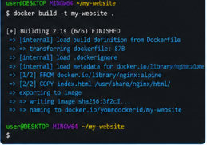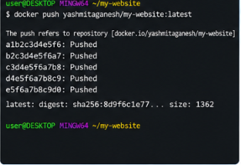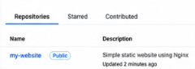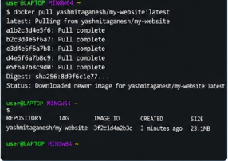
Screenshots

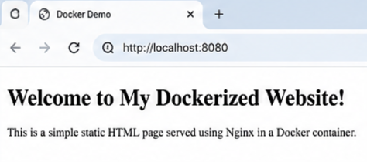

Observation
- Docker image was created successfully.
- Image was tagged with the Docker Hub repository name.
- Image was pushed successfully to Docker Hub.
- Image was pulled successfully on another machine.
- The container ran successfully.
- The website was accessible through the browser.

Result
The Docker image for the static HTML website was successfully created, tagged, and pushed to Docker Hub. The image was then pulled on another machine, the container was executed successfully, and the website was accessed through a web browser.

